Fantasy Football Team

Joshua Peterson

9/21/2016

Player analysis and selection for the week of 09.19.2016

QB Analysis - Pull Player Data

RB Analysis - Pull Player Data

# QB Analysis

## Cam Newton - Summary Passing & TD Data

## Min. 1st Qu. Median Mean 3rd Qu. Max.   
## 114.0 194.0 231.5 235.1 277.0 432.0

## Min. 1st Qu. Median Mean 3rd Qu. Max.   
## 0.000 1.000 1.000 1.525 2.000 5.000

## [1] 64.91911

## [1] 1.158076

## Andrew Luck - Summary Passing & TD Data

## Min. 1st Qu. Median Mean 3rd Qu. Max.   
## 109.0 202.0 257.0 270.5 333.0 433.0

## Min. 1st Qu. Median Mean 3rd Qu. Max.   
## 0.00 1.00 2.00 1.86 2.00 5.00

## [1] 76.94551

## [1] 1.231123

## Cam Newton - Histogram of Yards and TDs

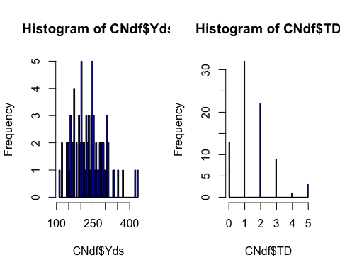

## Andrew Luck - Histogram of Yards and TDs

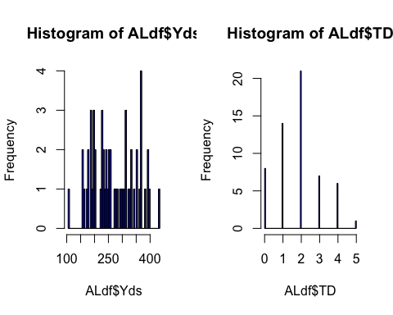

## Cam Newton - Least square estimate

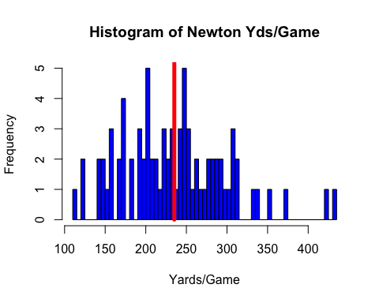

## Andrew Luck - Least square estimate

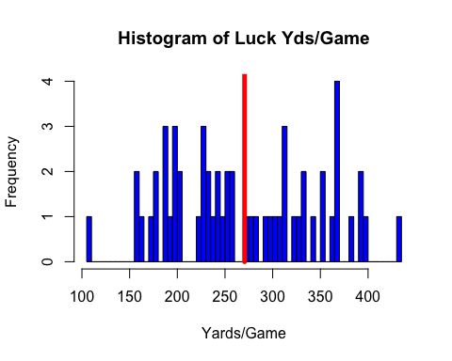

## Cam Newton - Current Opponent Analysis (Passing only)

## [1] 24.2

## [1] 16.33333

## [1] 40.53333

## Andrew Luck - Current Opponent Analysis (Passing only)

## [1] 20.2

## [1] 0

## [1] 20.2

# RB Analysis

## Blount - Summary Rushing TD Data

## Min. 1st Qu. Median Mean 3rd Qu. Max. NA's   
## -3.00 16.25 47.00 50.66 72.00 189.00 4

## Min. 1st Qu. Median Mean 3rd Qu. Max. NA's   
## 0.0000 0.0000 0.0000 0.4024 1.0000 3.0000 4

## [1] NA

## [1] NA

## Anderson - Summary Rushing TD Data

## Min. 1st Qu. Median Mean 3rd Qu. Max. NA's   
## -3.00 22.00 41.00 53.73 85.00 168.00 4

## Min. 1st Qu. Median Mean 3rd Qu. Max. NA's   
## 0.0000 0.0000 0.0000 0.4545 1.0000 3.0000 4

## [1] NA

## [1] NA

## Gore - Summary Rushing TD Data

## Min. 1st Qu. Median Mean 3rd Qu. Max.   
## 0.00 42.25 68.00 73.15 97.00 212.00

## Min. 1st Qu. Median Mean 3rd Qu. Max.   
## 0.0000 0.0000 0.0000 0.4217 1.0000 2.0000

## [1] 40.34061

## [1] 0.6251396

## Hyde - Summary Rushing TD Data

## Min. 1st Qu. Median Mean 3rd Qu. Max.   
## 0.00 16.50 34.00 40.22 50.50 168.00

## Min. 1st Qu. Median Mean 3rd Qu. Max.   
## 0.0000 0.0000 0.0000 0.3913 1.0000 2.0000

## [1] 36.63699

## [1] 0.6563764

## Blount - Histogram of Yards and TDs

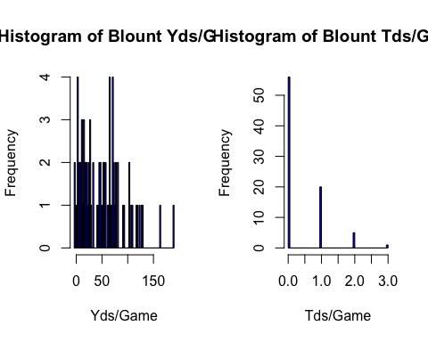

## Anderson - Histogram of Yards and TDs

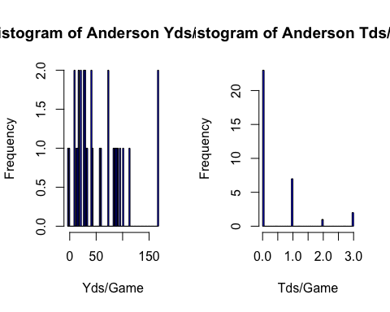

## Gore - Histogram of Yards and TDs

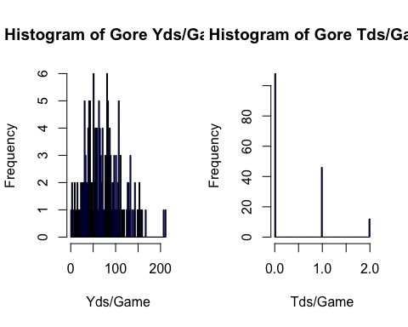

## Hyde - Histogram of Yards and TDs

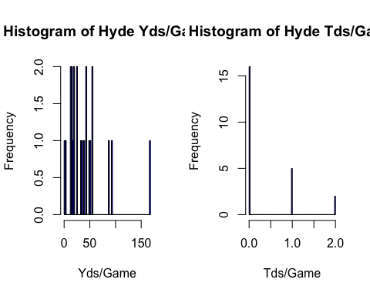

## Blount - Least square estimate

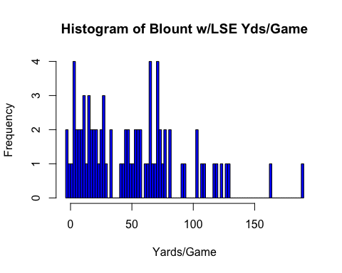

## Anderson - Least square estimate

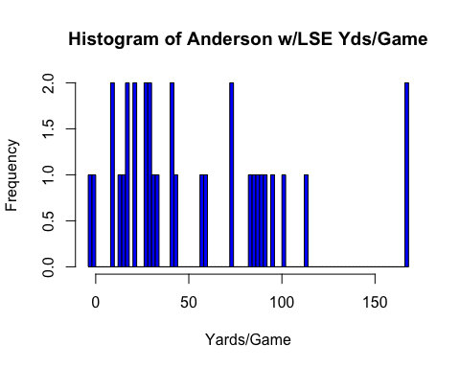

## Gore - Least square estimate

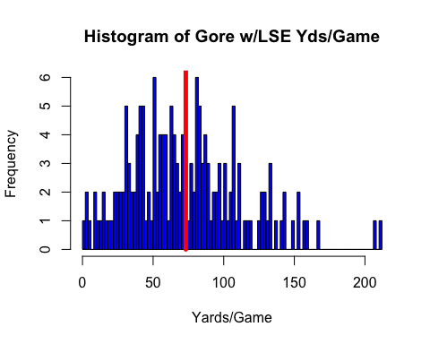

## Hyde - Least square estimate

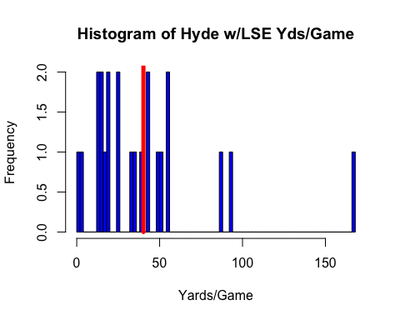

## Blount - Current Opponent Analysis (Rushing only)

## [1] 3.5

## [1] 1.75

## [1] 5.25

## Anderson - Current Opponent Analysis (Rushing only)

## [1] 7.8

## [1] 7

## [1] 14.8

## Gore - Current Opponent Analysis (Rushing only)

## [1] 10.65

## [1] 3.5

## [1] 14.15

## Hyde - Current Opponent Analysis (Rushing only)

## [1] 5

## [1] 3.5

## [1] 8.5